# Software

1. Download *Energia, KiCAD,* and *FreeCAD.* Links to download as well versions used at the time can be found in **Appendix ????**
2. Open Github Repository (<https://github.com/brandonhippe/412AirQualityCapstone>). Open the *Code* folder then add all the folders inside the *Libraries* folder inside the *Energia libraries* folder
3. Launch Energia and make sure to select the “MSP - EXP430FR2355LP” in the *board* section under the *Tools* tab
4. Upload the code found in the *sensor code* folder to Energia

# Hardware

**Part 1: Building Enclosure**

1. Go to GitHub Repository and save all the files saved under the *Enclosure* folder.

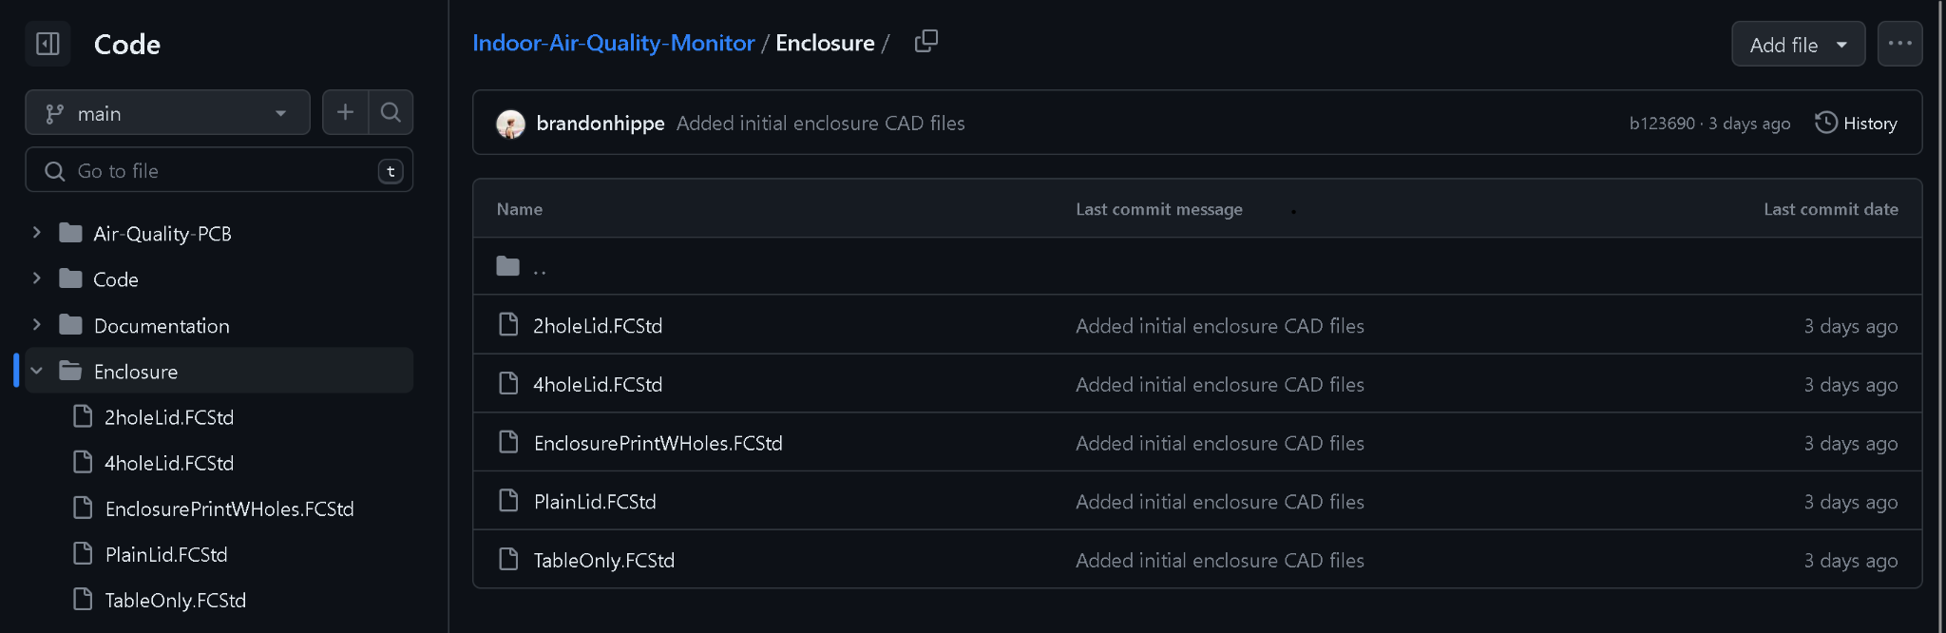

1. Open Files using *FreeCAD* to make any adjustments and print them to your 3D printer using the appropriate format for that printer
2. Assemble parts together once they finish printing

**Part 2: Building PCB**

1. Go to GitHub Repository and save all the .gbr files under the *Air-Quality-PCB* folder.

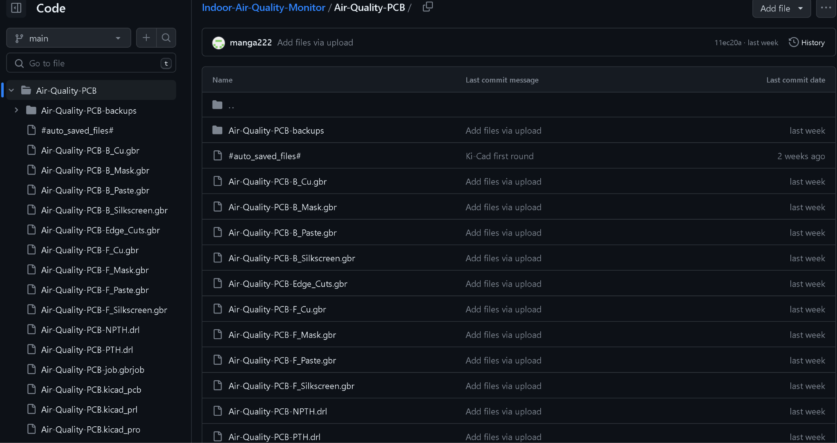

1. Open the website of your PCB manufacturer and go to their ordering page
   1. We used JLCPCB for the project as they were the cheapest and fastest at the time. Link can be found in **Appendix ????**
2. Drag and drop all the .gbr files
3. Select your options
   1. We selected the default options at time but chose to go with faster delivery
4. Solder on connection points so the MSP430 can be seated onto the PCB
5. Solder pins onto powerboost charger as well as the 3.3 converter
   1. We ended up removing LED(power and Low indicators) since they consumed too much power and were always on

## Appendix A: Troubleshooting

## Energia Issues

### Java Runtime Environment error

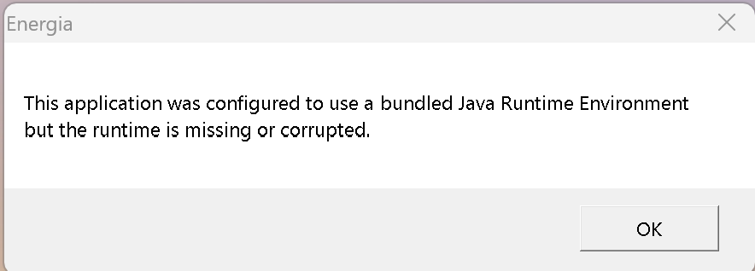

Solution:

To solve this issue, You must save *Energia* to your C: Folder and open it from there each time. The Desktop Shortcut will keep giving you this error.

Appendix B: Software links

List of used software and links:

1. Energia (<https://energia.nu/download/>)
2. KiCad(<https://www.kicad.org/download/>)
3. Github Repository(<https://github.com/brandonhippe/412AirQualityCapstone>)
4. FreeCAD (<https://www.freecad.org/downloads.php>)
5. JLCPCB (<https://cart.jlcpcb.com/quote>)

Versions used at time of build:

1. Energia 1.8.10E23
2. KiCad 7.0.2
3. FreeCAD 0.20.2